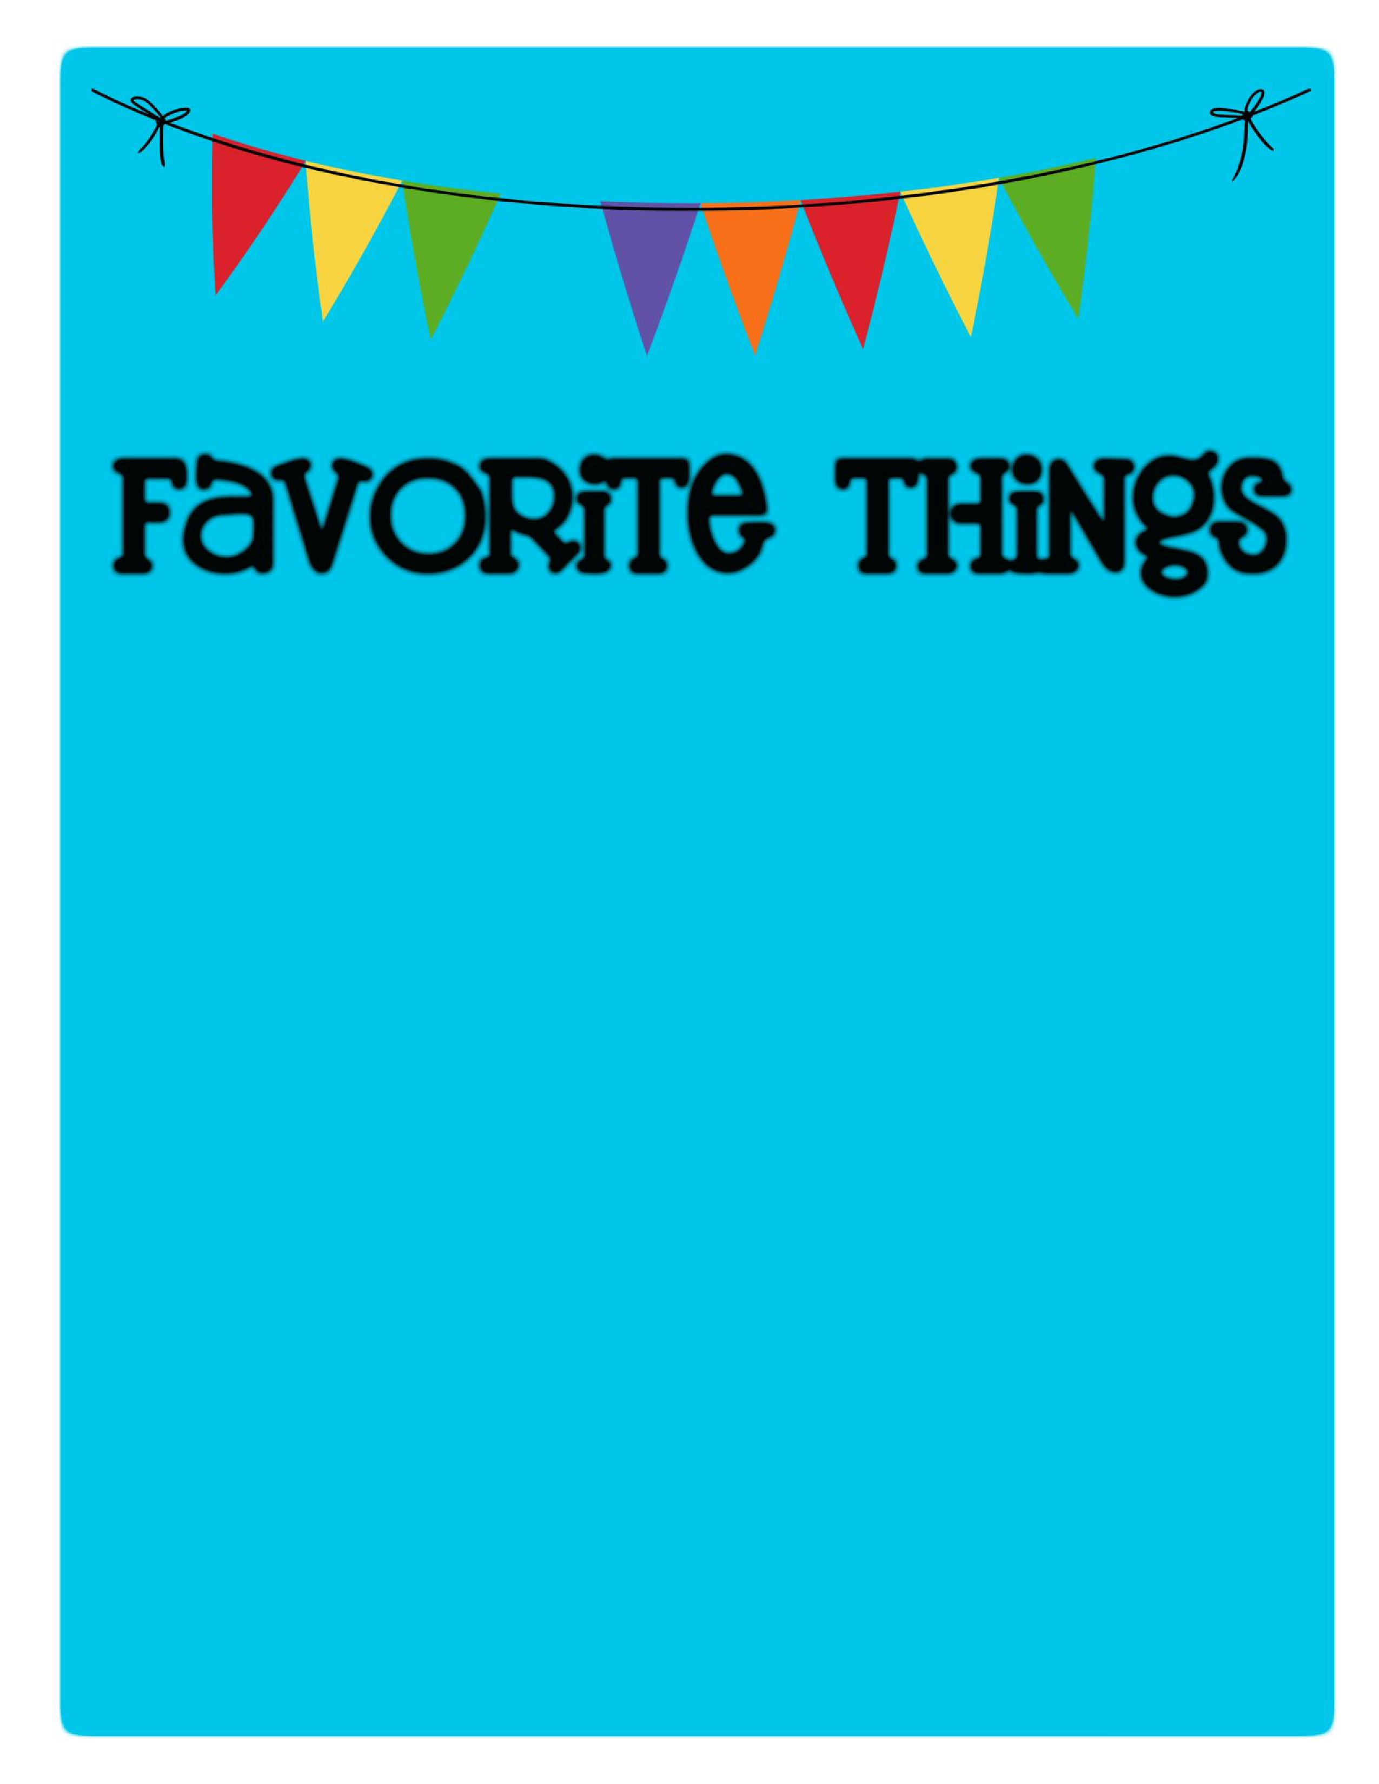

Name: Erika Moy _________________________

Birthday: _March 2nd

Favorites

Places to Eat: _Wildflowers, Blue Wasabi, Grimaldis, Someburros

Places to Shop:

_ Target, Athleta, Nordstrom Rack, TJ Maxx

Favorite Gift Cards:_ Target, Starbucks, Amazon

Drinks :

Starbucks

:

Hot Americano black, Iced Pikes Peak Coffee w/Oatmilk

Sonic

:

____________________________________

Other

:

___________________________________________

Scents (lotion, Scentsy, etc.): Cetaphil or Aveeno, Essential Oils

Candy/Snacks: Dark Chocolate, Cheese Popcorn, Doritos ________________________________

Cookies/Cake: Gluten Free Chocolate Chip Cookies, Chocolate Cake

Flowers

:

____

Roses or any

Hobbies/Collectibles: __Travel or Paint

Other Wish List Items: _